**CSA0410 – OPERATING SYSTEM LAB PROGRAMS**

*NAME:S.NAVYA*

*REG.NO:192110511*

**31. Construct a C program to simulate the First in First Out paging technique of memory management**.

#include<stdio.h>

#include<conio.h>

main()

{

int i, j, k, f, pf=0, count=0, rs[25], m[10], n;

printf("\n Enter the length of reference string -- ");

scanf("%d",&n);

printf("\n Enter the reference string -- ");

for(i=0;i<n;i++)

scanf("%d",&rs[i]);

printf("\n Enter no. of frames -- ");

scanf("%d",&f);

for(i=0;i<f;i++)

m[i]=-1;

printf("\n The Page Replacement Process is -- \n");

for(i=0;i<n;i++)

{

for(k=0;k<f;k++)

{

if(m[k]==rs[i])

break;

}

if(k==f)

{

m[count++]=rs[i];

pf++;

}

for(j=0;j<f;j++)

printf("\t%d",m[j]);

if(k==f)

printf("\tPF No. %d",pf);

printf("\n");

if(count==f)

count=0;

}

printf("\n The number of Page Faults using FIFO are %d",pf);

getch();

}

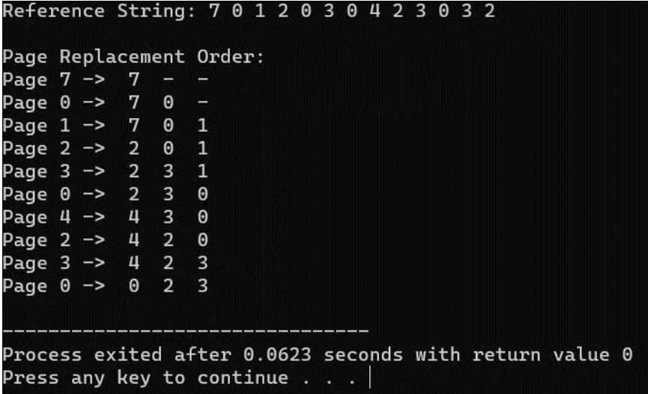

**32.Construct a C program to simulate the Least Recently Used paging technique of memory management**.

#include<stdio.h>

#include<conio.h>

main()

{

int i, j , k, min, rs[25], m[10], count[10], flag[25], n, f, pf=0, next=1;

printf("Enter the length of reference string -- ");

scanf("%d",&n);

printf("Enter the reference string -- ");

for(i=0;i<n;i++)

{

scanf("%d",&rs[i]);

flag[i]=0;

}

printf("Enter the number of frames -- ");

scanf("%d",&f);

for(i=0;i<f;i++)

{

count[i]=0;

m[i]=-1;

}

printf("\nThe Page Replacement process is -- \n");

for(i=0;i<n;i++)

{

for(j=0;j<f;j++)

{

if(m[j]==rs[i])

{

flag[i]=1;

count[j]=next;

next++;

}

}

if(flag[i]==0)

{

if(i<f)

{ m[i]=rs[i];

count[i]=next;

next++;

}

else

{ min=0;

for(j=1;j<f;j++)

if(count[min] > count[j])

min=j;

m[min]=rs[i];

count[min]=next;

next++;

}

pf++;

}

for(j=0;j<f;j++)

printf("%d\t", m[j]);

if(flag[i]==0)

printf("PF No. -- %d" , pf);

printf("\n");

}

printf("\nThe number of page faults using LRU are %d",pf);

getch();

}

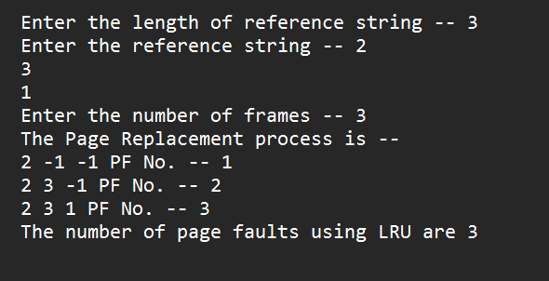

**33. Construct a C program to simulate the optimal paging technique of memory management.**

#include<stdio.h>

int main()

{

int no_of_frames, no_of_pages, frames[10], pages[30], temp[10], flag1, flag2,

flag3, i, j, k, pos, max, faults = 0;

printf("Enter number of frames: ");

scanf("%d", &no_of_frames);

printf("Enter number of pages: ");

scanf("%d", &no_of_pages);

printf("Enter page reference string: ");

for(i = 0; i < no_of_pages; ++i){

scanf("%d", &pages[i]);

}

for(i = 0; i < no_of_frames; ++i){

frames[i] = -1;

}

for(i = 0; i < no_of_pages; ++i){

flag1 = flag2 = 0;

for(j = 0; j < no_of_frames; ++j){

if(frames[j] == pages[i]){

flag1 = flag2 = 1;

break;

}

}

if(flag1 == 0){

for(j = 0; j < no_of_frames; ++j){

if(frames[j] == -1){

faults++;

frames[j] = pages[i];

flag2 = 1;

break;

}

}

}

if(flag2 == 0){

flag3 =0;

for(j = 0; j < no_of_frames; ++j){

temp[j] = -1;

for(k = i + 1; k < no_of_pages; ++k){

if(frames[j] == pages[k]){

temp[j] = k;

break;

}

}

}

for(j = 0; j < no_of_frames; ++j){

if(temp[j] == -1){

pos = j;

flag3 = 1;

break;

}

}

if(flag3 ==0){

max = temp[0];

pos = 0;

for(j = 1; j < no_of_frames; ++j){

if(temp[j] > max){

max = temp[j];

pos = j;

}

}

}

frames[pos] = pages[i];

faults++;

}

printf("\n");

for(j = 0; j < no_of_frames; ++j){

printf("%d\t", frames[j]);

}

}

printf("\n\nTotal Page Faults = %d", faults);

return 0;

}

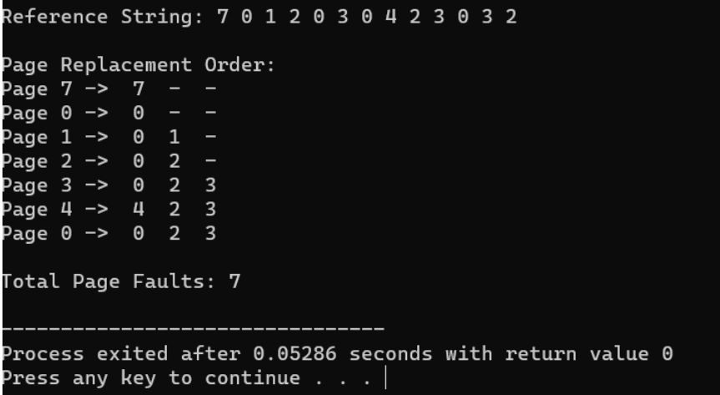

**34.Consider a file system where the records of the file are stored one after another both physically and logically. A record of the file can only be accessed by reading all the previous records. Design a C program to simulate the file allocation strategy**.

#include<stdio.h>

#include<conio.h>

#include<stdlib.h>

int main()

{

int f[50], i, st, len, j, c, k, count = 0;

for(i=0;i<50;i++)

f[i]=0;

x : count=0;

printf("Enter starting block and length of files: ");

scanf("%d%d", &st,&len);

for(k=st;k<(st+len);k++)

if(f[k]==0)

count++;

if(len==count)

{

for(j=st;j<(st+len);j++)

if(f[j]==0)

{

f[j]=1;

printf("%d\t%d\n",j,f[j]);

}

if(j!=(st+len-1))

printf("The file is allocated to disk\n");

}

else

printf("The file is not allocated \n");

printf("Do you want to enter more file(Yes - 1/No - 0)");

scanf("%d", &c);

if(c==1)

goto x;

else

exit(0);

getch();

}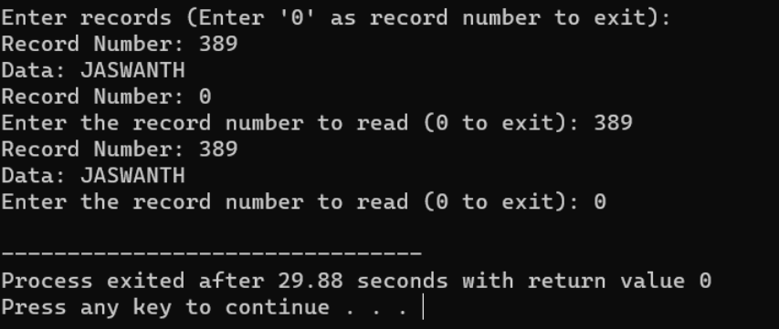

**35.Consider a file system that brings all the file pointers together into an index block. The ith entry in the index block points to the ith block of the file. Design a C program to simulate the file allocation strategy.**

#include<stdio.h>

#include<conio.h>

#include<stdlib.h>

int main()

{

int f[50], index[50],i, n, st, len, j, c, k, ind,count=0;

for(i=0;i<50;i++)

f[i]=0;

x:printf("Enter the index block: ");

scanf("%d",&ind);

if(f[ind]!=1)

{

printf("Enter no of blocks needed and no of files for the index %d on the disk :

\n", ind);

scanf("%d",&n);

}

else

{

printf("%d index is already allocated \n",ind);

goto x;

}

y: count=0;

for(i=0;i<n;i++)

{

scanf("%d", &index[i]);

if(f[index[i]]==0)

count++;

}

if(count==n)

{

for(j=0;j<n;j++)

f[index[j]]=1;

printf("Allocated\n");

printf("File Indexed\n");

for(k=0;k<n;k++)

printf("%d-------->%d : %d\n",ind,index[k],f[index[k]]);

}

else

{

printf("File in the index is already allocated \n");

printf("Enter another file indexed");

goto y;

}

printf("Do you want to enter more file(Yes - 1/No - 0)");

scanf("%d", &c);

if(c==1)

goto x;

else

exit(0);

getch();

}

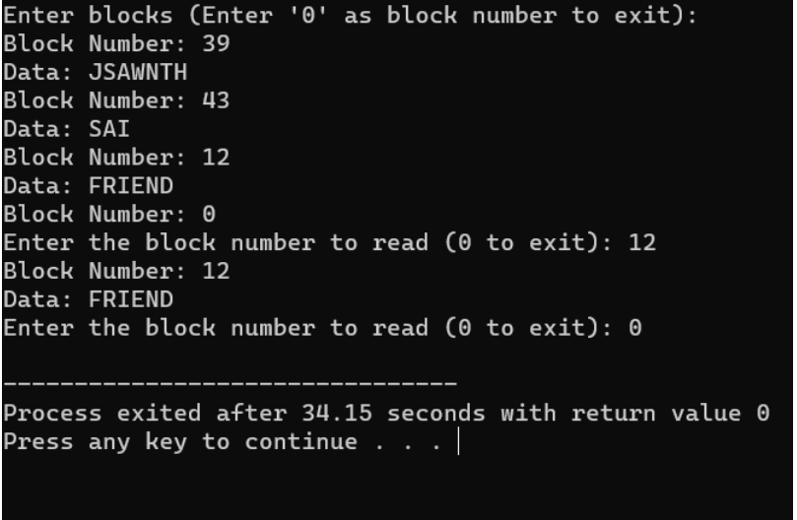

**36.With linked allocation, each file is a linked list of disk blocks; the disk blocks may be scattered anywhere on the disk. The directory contains a pointer to the first and last blocks of the file. Each block contains a pointer to the next block. Design a C program to simulate the file allocation strategy**.

#include<conio.h>

#include<stdlib.h>

int main()

{

int f[50], p,i, st, len, j, c, k, a;

for(i=0;i<50;i++)

f[i]=0;

printf("Enter how many blocks already allocated: ");

scanf("%d",&p);

printf("Enter blocks already allocated: ");

for(i=0;i<p;i++)

{

scanf("%d",&a);

f[a]=1;

}

x: printf("Enter index starting block and length: ");

scanf("%d%d", &st,&len);

k=len;

if(f[st]==0)

{

for(j=st;j<(st+k);j++)

{

if(f[j]==0)

{

f[j]=1;

printf("%d-------->%d\n",j,f[j]);

}

else

{

printf("%d Block is already allocated \n",j);

k++;

}

}

}

else

printf("%d starting block is already allocated \n",st);

printf("Do you want to enter more file(Yes - 1/No - 0)");

scanf("%d", &c);

if(c==1)

goto x;

else

exit(0);

}

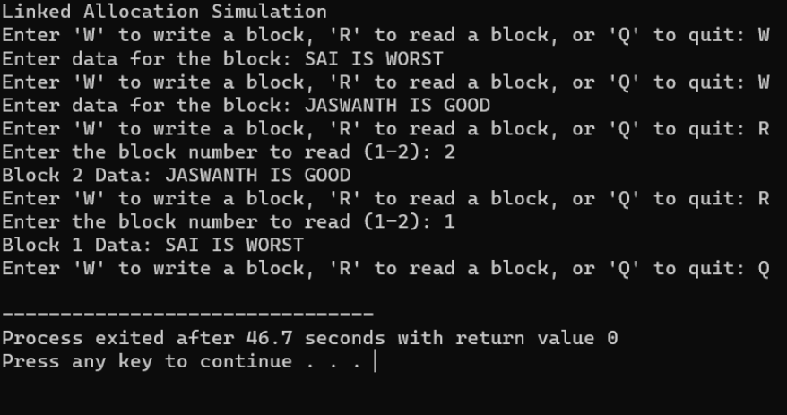

**37.Construct a C program to simulate the First Come First Served disk scheduling algorithm**.

#include<stdio.h>

#include<stdlib.h>

int main()

{

int RQ[100],i,n,TotalHeadMoment=0,initial;

printf("Enter the number of Requests\n");

scanf("%d",&n);

printf("Enter the Requests sequence\n");

for(i=0;i<n;i++)

scanf("%d",&RQ[i]);

printf("Enter initial head position\n");

scanf("%d",&initial);

for(i=0;i<n;i++)

{

TotalHeadMoment=TotalHeadMoment+abs(RQ[i]-initial);

initial=RQ[i];

}

printf("Total head moment is %d",TotalHeadMoment);

return 0;

}

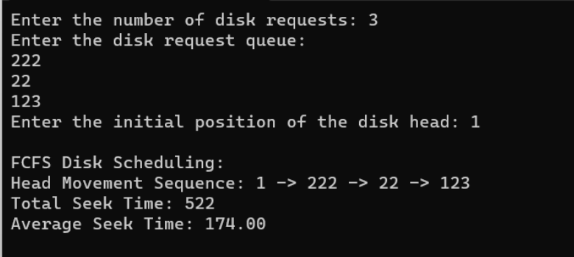

**38.Design a C program to simulate SCAN disk scheduling algorithm.**

#include <stdio.h>

#include <stdlib.h>

int main() {

int n, head, direction, total_head_movement = 0;

printf("Enter the number of disk requests: ");

scanf("%d", &n);

int requests[n];

printf("Enter the disk requests:\n");

for (int i = 0; i < n; i++) {

scanf("%d", &requests[i]);

}

printf("Enter the initial head position: ");

scanf("%d", &head);

printf("Enter the head movement direction (1 for right, 0 for left): ");

scanf("%d", &direction);

// Sort the requests to make it easier to simulate SCAN

for (int i = 0; i < n - 1; i++) {

for (int j = i + 1; j < n; j++) {

if ((direction == 1 && requests[i] > requests[j]) || (direction == 0 &&

requests[i] < requests[j])) {

int temp = requests[i];

requests[i] = requests[j];

requests[j] = temp;

}

}

}

int index = 0;

for (int i = 0; i < n; i++) {

if ((direction == 1 && requests[i] > head) || (direction == 0 && requests[i] <

head)) {

index = i;

break;

}

}

if (direction == 1) {

for (int i = index; i < n; i++) {

total_head_movement += abs(requests[i] - head);

head = requests[i];

}

total_head_movement += abs(requests[n - 1] - (direction == 1 ? 0 : 0));

} else {

for (int i = index - 1; i >= 0; i--) {

total_head_movement += abs(requests[i] - head);

head = requests[i];

}

total_head_movement += abs(requests[0] - (direction == 1 ? 0 : 0));

}

printf("Total head movement is: %d\n", total_head_movement);

return 0;

}

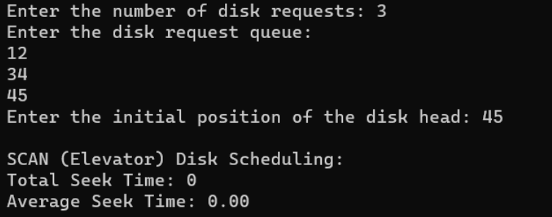

**39. Develop a C program to simulate C-SCAN disk scheduling algorithm.**

#include<stdio.h>

#include<stdlib.h>

int main()

{

int RQ[100],i,j,n,TotalHeadMoment=0,initial,size,move;

printf("Enter the number of Requests\n");

scanf("%d",&n);

printf("Enter the Requests sequence\n");

for(i=0;i<n;i++)

scanf("%d",&RQ[i]);

printf("Enter initial head position\n");

scanf("%d",&initial);

printf("Enter total disk size\n");

scanf("%d",&size);

printf("Enter the head movement direction for high 1 and for low 0\n");

scanf("%d",&move);

for(i=0;i<n;i++)

{

for( j=0;j<n-i-1;j++)

{

if(RQ[j]>RQ[j+1])

{

int temp;

temp=RQ[j];

RQ[j]=RQ[j+1];

RQ[j+1]=temp;

}

}

}

int index;

for(i=0;i<n;i++)

{

if(initial<RQ[i])

{

index=i;

break;

}

}

if(move==1)

{

for(i=index;i<n;i++)

{

TotalHeadMoment=TotalHeadMoment+abs(RQ[i]-initial);

initial=RQ[i];

}

TotalHeadMoment=TotalHeadMoment+abs(size-RQ[i-1]-1);

TotalHeadMoment=TotalHeadMoment+abs(size-1-0);

initial=0;

for( i=0;i<index;i++)

{

TotalHeadMoment=TotalHeadMoment+abs(RQ[i]-initial);

initial=RQ[i];

}

}

else

{

for(i=index-1;i>=0;i--)

{

TotalHeadMoment=TotalHeadMoment+abs(RQ[i]-initial);

initial=RQ[i];

}

TotalHeadMoment=TotalHeadMoment+abs(RQ[i+1]-0);

TotalHeadMoment=TotalHeadMoment+abs(size-1-0);

initial =size-1;

for(i=n-1;i>=index;i--)

{

TotalHeadMoment=TotalHeadMoment+abs(RQ[i]-initial);

initial=RQ[i];

}

}

printf("Total head movement is %d",TotalHeadMoment);

return 0;

}

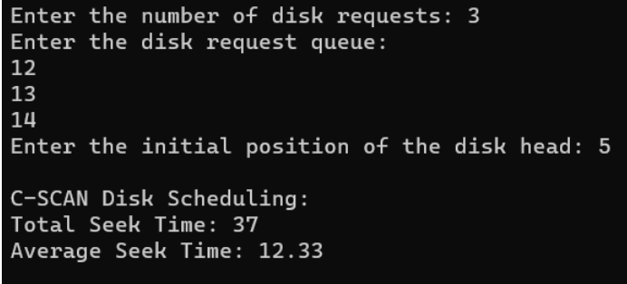**40. Illustrate the** various **File Access Permission and different types users in Linux.**

#include <stdio.h>

#include <stdlib.h>

#include <string.h>

#include <unistd.h>

int main(int argc, char **argv) {

int result;

char *filename = (char *)malloc(512);

if (argc < 2) {

strcpy(filename, "/usr/bin/adb");

} else {

strcpy(filename, argv[1]);

}

result = access (filename, R_OK);

if ( result == 0 ) {

printf("%s is readable\n",filename);

} else {

printf("%s is not readable\n",filename);

}

result = access (filename, W_OK);

if ( result == 0 ) {

printf("%s is Writeable\n",filename);

} else {

printf("%s is not Writeable\n",filename);

}

result = access (filename, X_OK);

if ( result == 0 ) {

printf("%s is executable\n",filename);

} else {

printf("%s is not executable\n",filename);

}

free(filename);

return 0;

}

